ADULT EXERCISE EQUIPMENT SURVEY
Would you be interested in this?
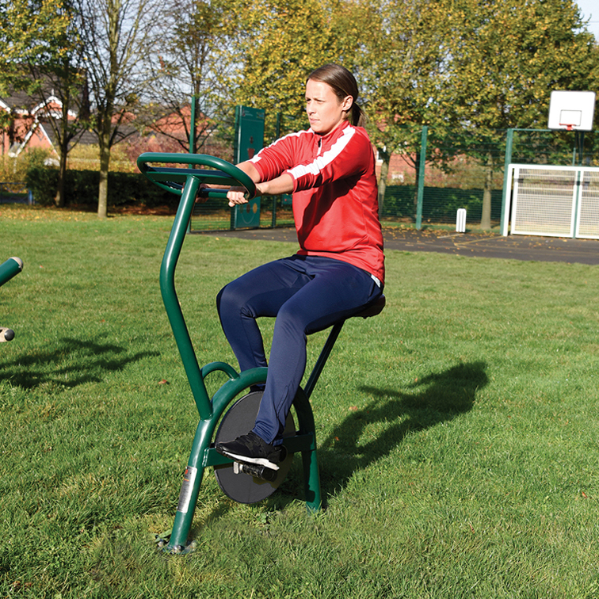

Outdoor gyms have been gaining in popularity in recent years and can be a fun way to built up fitness and strength. Perhaps Bodenham residents would welcome the installation of adult exercise equipment. The Parish Council would like to know your views and to see how much demand there is.
Please complete the short questionnaire. It can be returned via the boxes situated inside Bodenham Post Office and Saffrons Garage. Alternatively return it to 19 Siward James Close, Bodenham, or e-mail to bodenhampcclerk@gmail.com. Please return by 28th February. Thank you.
QUESTIONNAIRE
- Would you use adult exercise equipment on a regular basis? How often do you think you would use it?

- Different pieces of equipment are available. Some are designed to exercise different parts of the body, and/or develop skills. Do you have a preference for any particular pieces of equipment, such as Arm and Pedal Bicycle, Balance Beams?

- Where in the Parish do you think would be the most appropriate place to site the equipment?

- Have you seen, or used, such equipment anywhere else? If so, what was your experience?

Thank you for your time. Your views are much appreciated. Please return this form via the boxes inside Bodenham Post Office, or Saffrons Garage. You can also e-mail bodenhampcclerk@gmail.com or post to 19 Siward James Close, Bodenham, by 28th February.

